Like* Anova 1

Q1: Is Like* used in one context more than in another context?

|  |  |  |  |  |  |  |  |  |
| --- | --- | --- | --- | --- | --- | --- | --- | --- |
|  | Apt | Outdoors | In transit | In transit other | Restaurant | Shopping | Other public place | Classroom |
| Apartment |  |  |  |  |  |  |  |  |
| Outdoors | .000 |  |  |  |  |  |  |  |
| In transit | .000 | .600 |  |  |  |  |  |  |
| In transit other | .000 | .771 | .017 |  |  |  |  |  |
| Restaurant | .000 | .999 | .255 | .972 |  |  |  |  |
| Shopping | .000 | .679 | .010 | 1.00 | .941 |  |  |  |
| Other public place | .000 | .999 | .929 | .362 | .941 | .278 |  |  |
| Classroom | .000 | .771 | .017 | 1.00 | .972 | 1.00 | .362 | 1.00 |

Apartment

Outdoors

In transit

In transit other

Restaurant

Shopping

Other public place

Classroom

Classroom

Other public place

Shopping

Restaurant

In transit other

In transit

Outdoors

Apartment

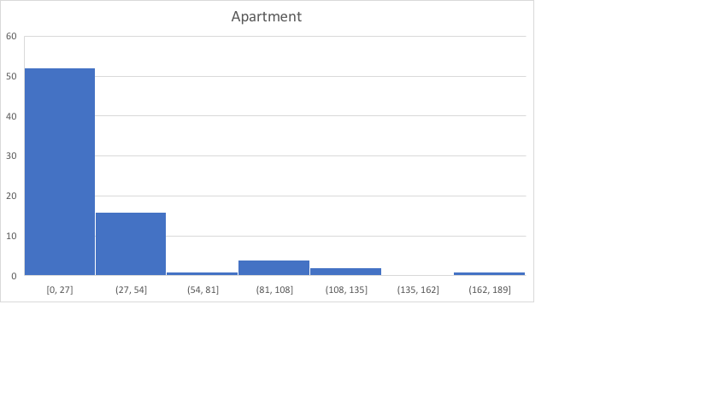

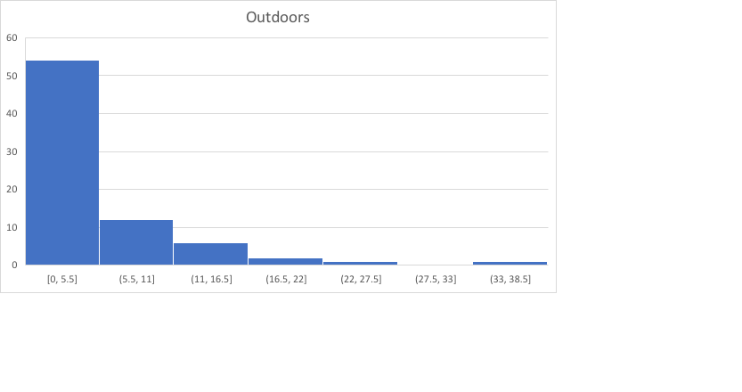

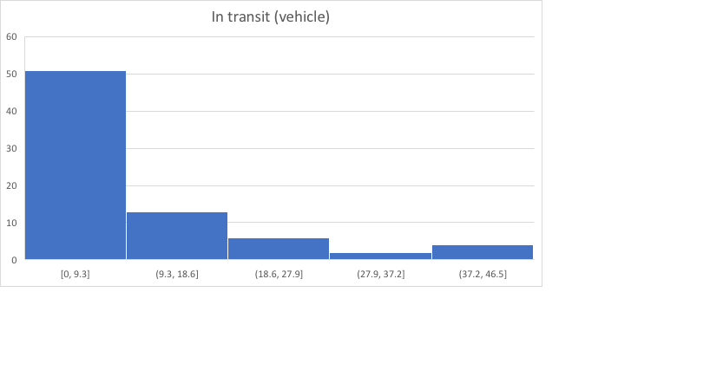

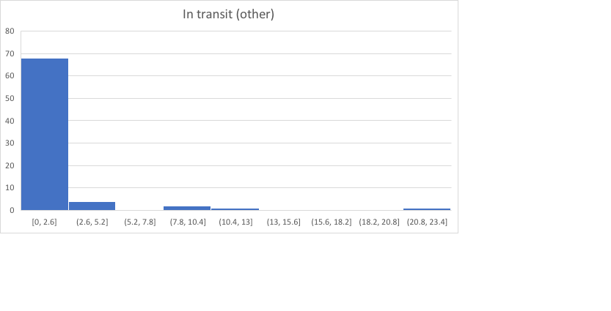

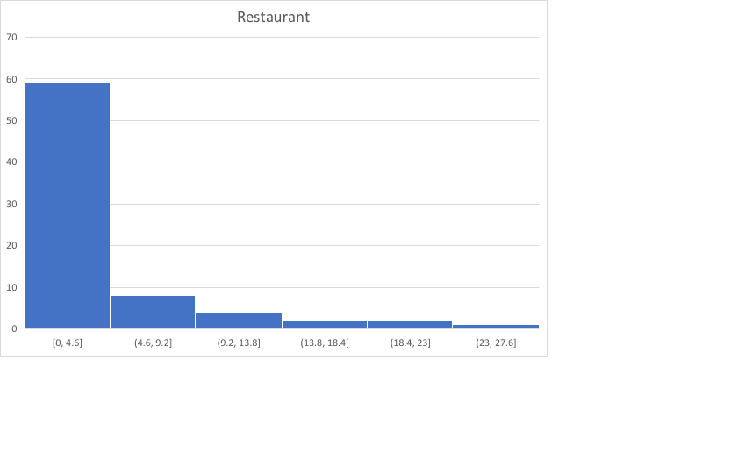

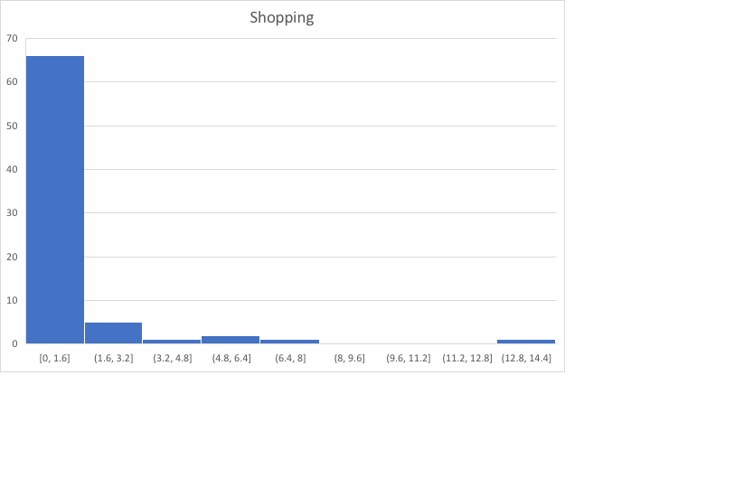

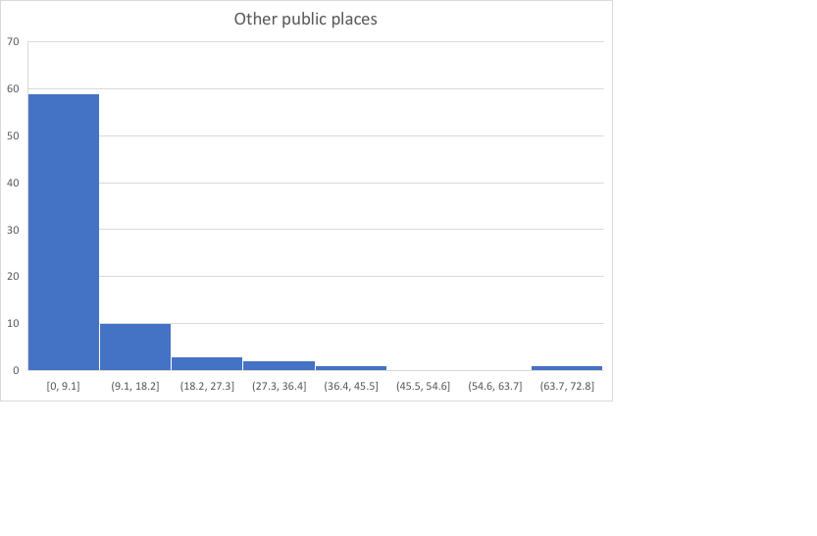

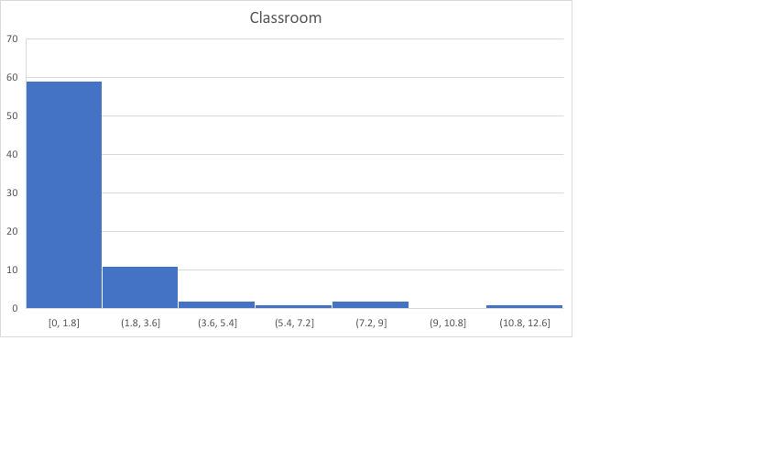

Like* Anova 2

Q1: Is Like* (individual proportions) used in one context more than in another context?

|  |  |  |  |  |  |  |  |
| --- | --- | --- | --- | --- | --- | --- | --- |
|  | Apt | In transit | In transit other | Restaurant | Shopping | Other public place | Classroom |
| Apartment |  |  |  |  |  |  |  |
| In transit | .986 |  |  |  |  |  |  |
| In transit other | .000 | .000 |  |  |  |  |  |
| Restaurant | .802 | .996 | .000 |  |  |  |  |
| Shopping | 1.00 | .999 | .000 | .918 |  |  |  |
| Other public place | .670 | .981 | .000 | 1.00 | .827 |  |  |
| Classroom | 1.00 | .993 | .000 | .851 | 1.00 | .723 |  |

|  |  |  |  |  |  |  |
| --- | --- | --- | --- | --- | --- | --- |
| 21% | 16% | 50% | 12% | 19% | 11% | 20% |

